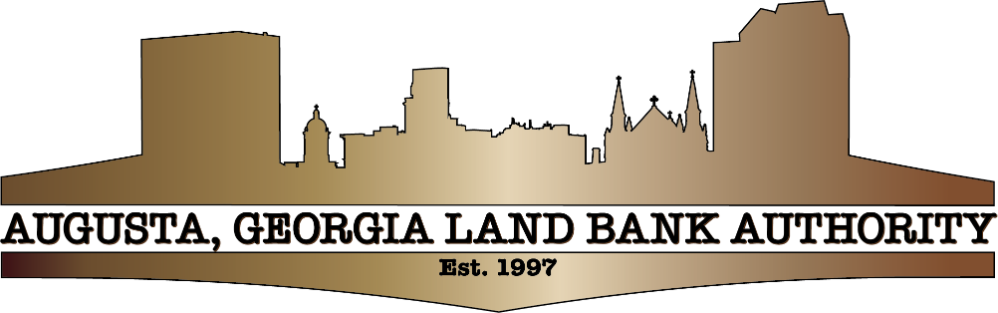

AGLBA Monthly Meeting
-AGENDA-
Enterprise Mill - First Floor Conference Room
1450 Greene Street, Augusta, GA 30901
Wednesday, March 5, 2025– 2:00pm -3:00pm

- OPENING REMARKS

- AGLBA Chairman - Tederell (Chris) Johnson

- REQUESTS FOR APPROVAL

- Approve AGLBA Meeting Minutes of February 12, 2025-AGLBA Chairman, Tederell (Chris) Johnson, Presenting

- Approve Request from Brandon R. Johnson to Purchase AGLBA parcel located at 1417 Roulette Lane for Construction of a Multi Family Home-Brandon R. Johnson, Presenting

3.ITEMS FOR DISCUSSION

- Update on Foreclosures & Donations Listing-AGLBA Attorney John Manton, Presenting

- Review Draft of AGLBA 501(c)(3) Bylaws- Executive Director, Shawn Edwards, Presenting

4. ADJOURNMENT

